PROJECT TITLE: MicroGoals – Secure Goal Management API

TEAM LEADER: Hema U hemaumpathy3@gmail.com

TEAM ID: SWTID-2026-5037

TEAM MEMBERS:
- MONISHA. A monishaanbu46@gmail.com
- KALAI SELVI .M kalaisamy.0506@gamil.com
- ANITHA.K anith1309@gmail.com

Introduction About MicroGoals – Secure Goal Management API :

- Backend REST API built with Node.js, Express.js, and MongoDB to allow users to register, log in, and manage personal goals securely.

- PROJECT CONFIGRATION & SETUP
- Folder structure
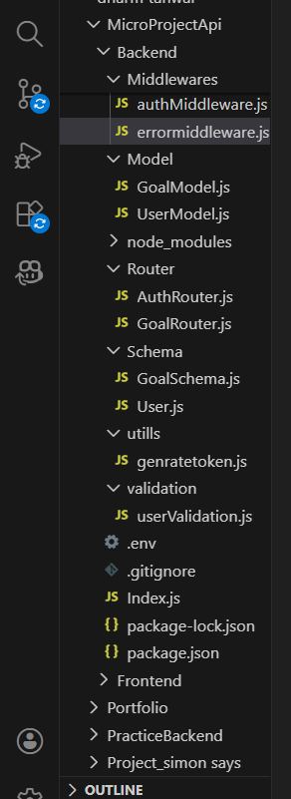

Key Features :
• Secure user authentication
• Personal goal management
• User-specific data access
• Protected API endpoints
• Proper error handling

Project Overview :
- MicroGoals is a backend system that supports goal tracking with authentication. It provides CRUD operations for goals and uses JWT tokens to ensure secure user access.

Main System Functions :
• User Registration and Login
• JWT Authentication
• Create, Read, Update, Delete Goals
• Protected API Routes
• Centralized Error Handling
Project Guidelines :
• Designed using REST API standards
• Authentication handled with JWT
• MongoDB used as database
• APIs tested using Thunder Client
• MVC architecture followed

Prerequisites :
• Node.js (v18+)
• Express.js
• MongoDB (Local or Atlas)
• VS Code
• Thunder Client Extension
• Basic JavaScript & REST API knowledge

Technical Architecture :
- Runtime: Node.js
- Framework: Express.js

- Database: MongoDB
- Authentication: JWT
Architecture Pattern: MVC
ER Diagram Concept :
- Entities:
- User: id, name, email, password
- Goal: id, title, completed, userId
- Relationship: One User can have Multiple Goals

Roles and Responsibilities :
- User: Register, login and manage goals
- Developer: Design, develop and test the API

User Workflow :
1. User signs up
2. User logs in
3. JWT token is generated

4. Token sent with request header
5. Access secured routes
6. Perform goal CRUD operations

Project Setup :
1. npm init -y
2. Install dependencies: express, mongoose, jsonwebtoken, bcryptjs, dotenv
3. Run server using node server.js

Backend Development:
• Express server created
• MongoDB database connected
• Authentication APIs implemented
• Goal CRUD APIs implemented
• Middleware added for security

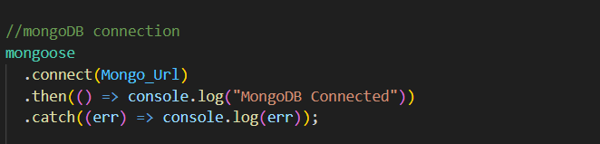

- Implemented Authentication APIs
User registration and login APIs were created with password hashing and JWT token generation for secure authentication.

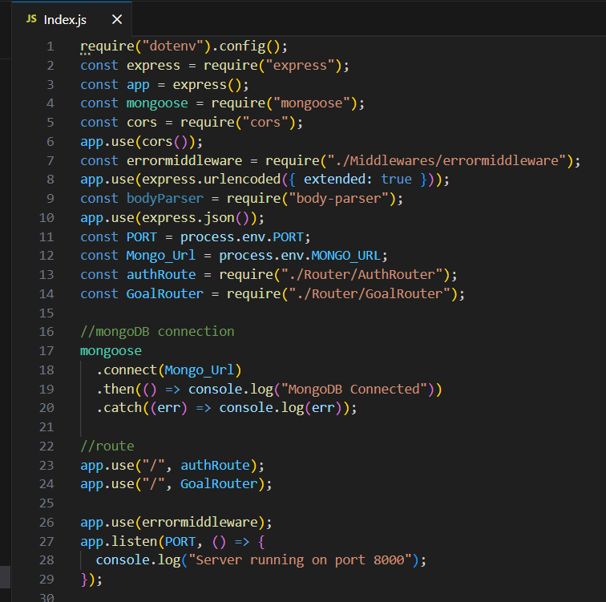
- Connected MongoDB
For Connection with MongoDB:-

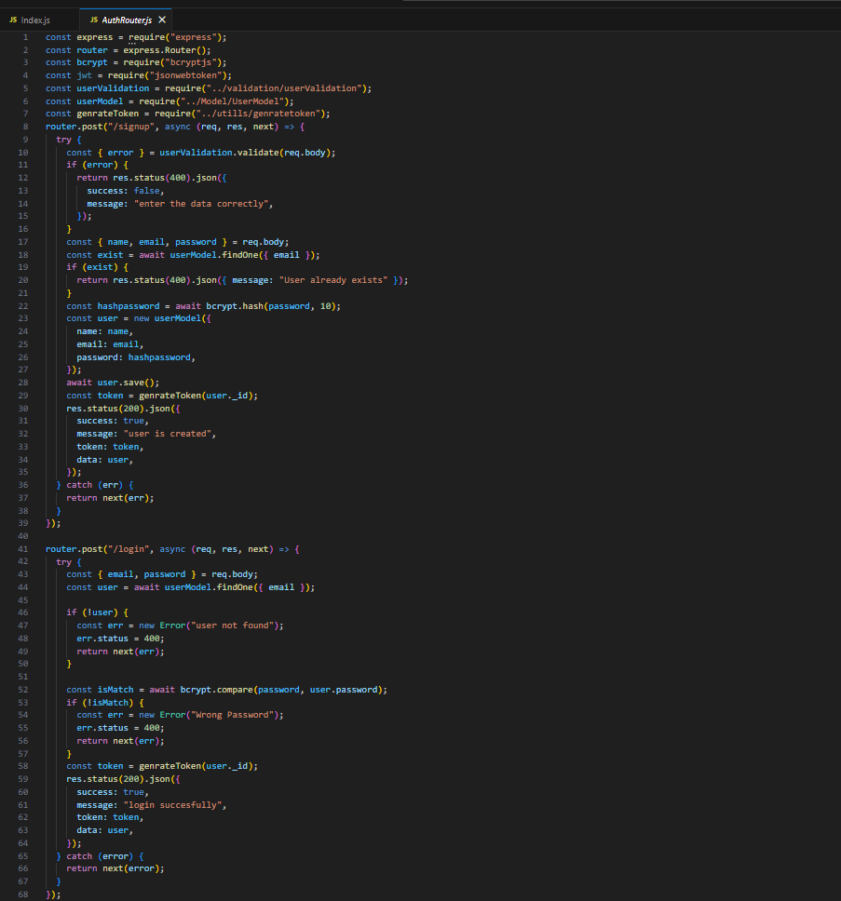
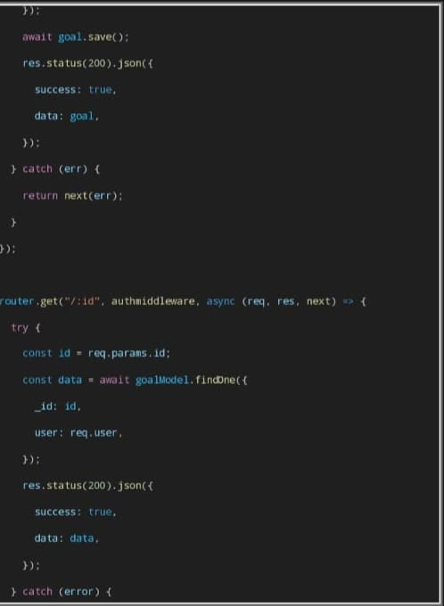
● Added Error Middleware
An error middleware was added to handle application errors centrally and return proper status codes and messages
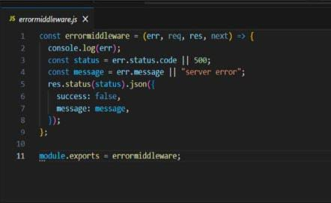

DatebaseDevelopment :
- MongoDB configured using Atlas or Local server.
- Connection string stored in .env file.
- Mongoose used for database connection.

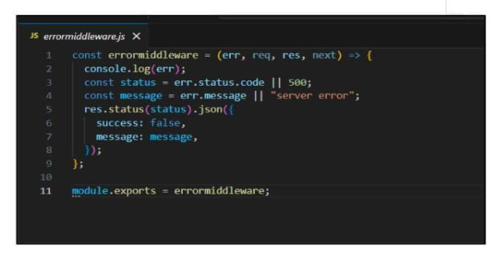
Schemas and Models :
- User Schema: name, email, password
- Goal Schema: title, completed status, userId reference to user.

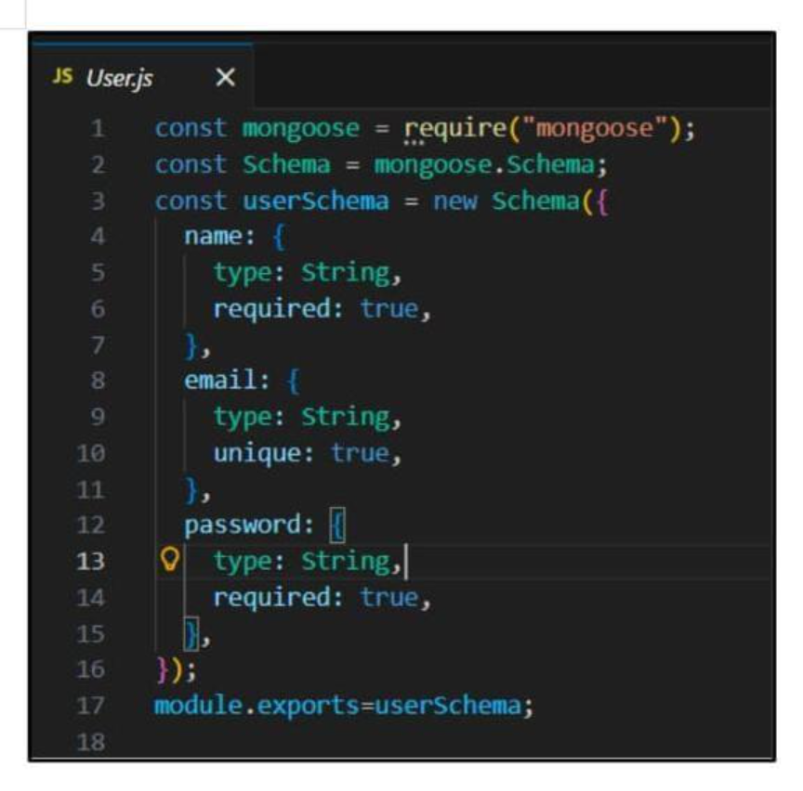

Project Execution :
1. Start MongoDB
2. Run backend server
3. Test APIs in Thunder Client
4. Register user
5. Login and obtain token
6. Perform CRUD operations

Output Demonstrations :
• User registration and login success
• JWT token generation
• Goal creation
• Protected routes validation

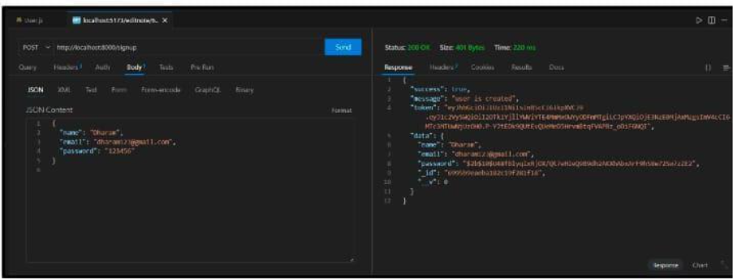

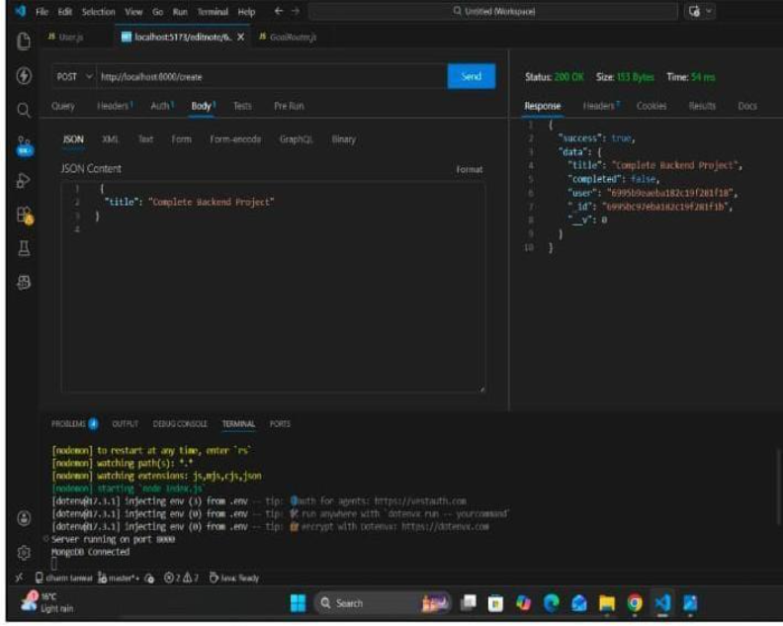
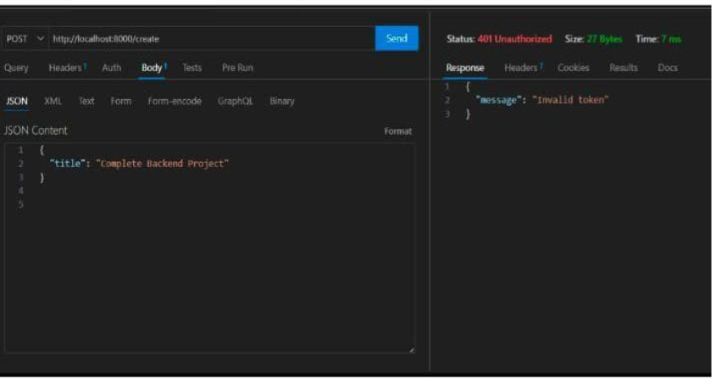

Project Demo :
- Video demonstration includes:
- User registration
- Login process
- Token usage
- CRUD operations
Error handling

